**Revision Notes on Water: A Precious Resource**

**Quick Facts**

* 22 March is celebrated as World Water Day to bring awareness among the people about the conservation of water.
* 2003 was called as the International year of freshwater to bring awareness among the people about the importance of water as a resource and why it is depleting at such a fast rate.

**How much water is available on the earth?**

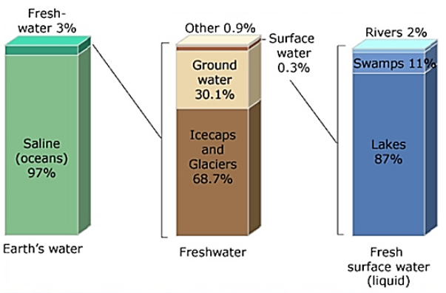

**Figure 1: Distribution of Water on Earth**

* 71% of the Earth is covered with water. However, all of that cannot be consumed by the living organisms.
* The figure given above represents that 97% of the earth's water is saline that is present in the oceans and 3% of the earth's water is fresh that is present in ice caps, glaciers and underground. This fresh water can be obtained from underground, rivers and lakes. Even then, just 1 percent of our freshwater is easily accessible, with much of it trapped in glaciers and snowfields.

**Different forms of Water**

* **Solid State** - Water exists in the solid form as ice and snow on the earth.
* **Liquid State** - Water exist in the liquid state in rivers lakes, oceans and under the ground.
* **Gaseous State** - Water exists as water vapour in the atmosphere.

**The Water Cycle**

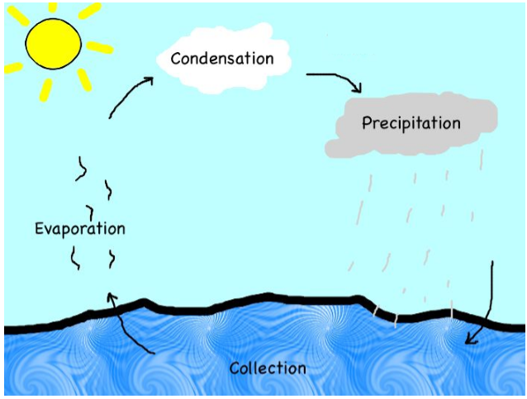

**Figure 2: The Water Cycle**

The water cycle is a natural process that continuously happens on earth. The water cycle maintains the amount of water on the earth. It can be divided into four phases:

* **Evaporation** - It is a process when the water from the earth’s surface gets converted into water vapour due to the heat of the sun. The water vapour then gets into the air.
* **Condensation** - The water vapour rises up in the atmosphere and get accumulated above, condenses and form water droplets. These droplets collect together and form clouds.
* **Precipitation** - When the volume of droplets increases in the atmosphere, it falls on the earth as rainfall also called as **Precipitation**. Sometimes it also occurs as snowfall in some areas.
* **Collection of Water** - As the water falls back on the earth, it travels along the surface and gets accumulated at different places like lakes, rivers, sea, oceans and under the ground. That's how the amount of water is regulated on the earth.

**Groundwater**

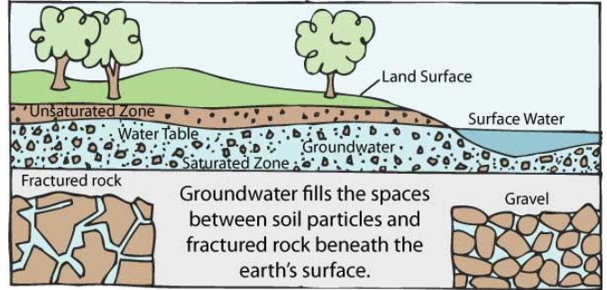

**Figure 3: Groundwater**

* The water that falls on the earth’s surface slips inside the earth and gets accumulated in the cracks and gaps of the rocks present inside the earth.
* The water table is called the upper limit of the layer of water present beneath the earth. The water table can vary from one place to another.
* The water that is present beneath the water table of a place is called **Groundwater**. This water gets accumulated inside the earth because of different sources:
  + Rainwater that falls on the earth slips inside the ground
  + Water in the rivers, lakes and Ponds often slips into the earth and get accumulated as groundwater
* **Infiltration -** The process by which water accumulates into the ground by travelling through the soil pores is called **Infiltration**.

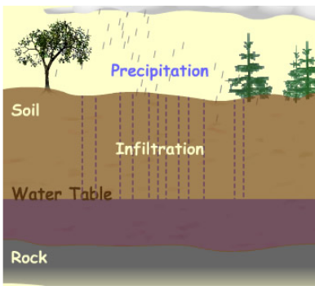

**Figure 4: Infiltration**

* **Aquifer -** The underground layer of rocks that contain water present between their cracks and empty spaces is called **Aquifer**.

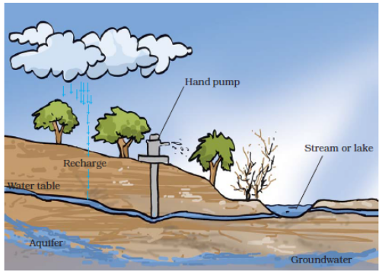

**Figure 5: Aquifer and Groundwater**

**How underground water can be obtained?**

Groundwater is generally obtained by digging Wells, using hand pumps and electric pumps.

**Uses of Groundwater**

Groundwater is fresh water and therefore can be used for various purposes such as:

* consumption or drinking water
* domestic chores
* irrigation of crops
* water services in public buildings and offices
* firefighting
* industrial purposes

**Water Table Depletion**

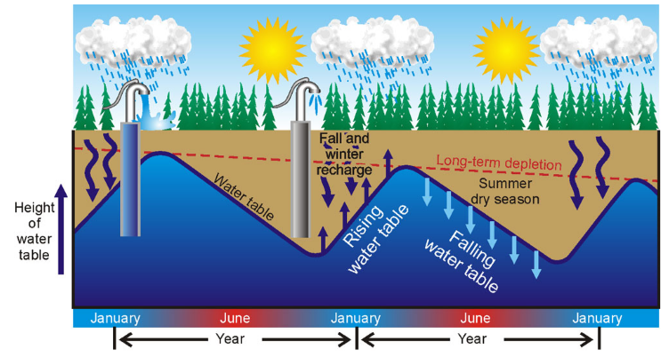

**Figure 6: How Water table gets affected in different seasons**

The water table of a place may decrease if we keep on taking out more water than what is getting replenished due to rainfall. There are several factors that can cause water table depletion:

**1. Increasing Population**

* As the population of a region increases the demand of freshwater also rises sharply. This means more water is being required.
* Also, increasing population demands more space which leads to the construction of more houses, shops, industries, buildings and roads.
* The number of places like parks, grounds or forests decreases.
* All this reduces the possibility of rainwater getting into the soil particles because the concrete floors and roads to not allow seepage of water.
* This means that an increased demand and usage of groundwater as compared to the replenishment of water tables.
* This results in depletion of the water table of that region.

**2. Increasing Industries**

Every industry requires water in its production process. As a number of industries increases, more water is drawn from the ground. All of this result in depletion of the water table.

**3. Agricultural Activities**

In case of no or low rainfall, farmers use groundwater to irrigate their land for agriculture. This depletes the water table over the years.

**4. Deforestation**

We know that plants and trees keep the soil bounded together and allow absorption of water in the soil. Uprooting them exposes the first layer of the soil which can get washed away easily. This affects the water table of that region.

**5. Low Rainfall**

In places where there is low or scanty rainfall the underground water table is generally low.

**Distribution of Water**

* The distribution of water across the earth is not even due to different factors such as rainfall and climatic conditions.
* Some places have a high amount of water while others face scarcity of water.
* For Example, in India, places like Rajasthan get very low rainfall and hence have less water. On the other hand, places like Meghalaya receive high rainfall and have a high amount of water. Hence, there can be times when one part of India faces floods while other is suffering from a drought -like condition.

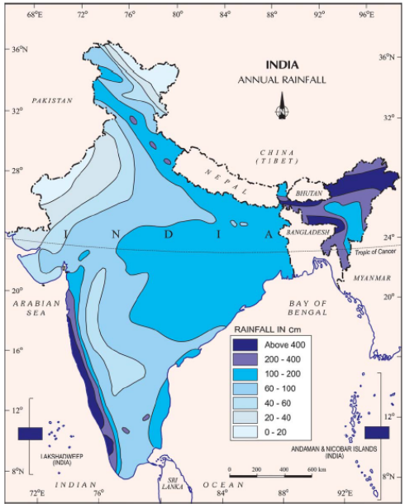

**Figure 7: Rainfall in India**

**Water Management**

* No matter whether a place receives a high rainfall or low rainfall, water management is necessary to ensure that everyone gets access to an adequate amount of water.
* Generally, the Civic authorities of a region are responsible for the adequate supply of water in that area.
* They generally use a well-structured pipeline system to deliver water to every house and building of the locality.
* Not only this it is also a responsibility of the civic authorities to prevent wastage of water and check if their supply system is adequate or not.
* Along with these authorities, every individual is also responsible for saving water and preventing it from getting wasted. Hence, we should always keep a check on how we use water in our daily lives.

**Water Harvesting or Rainwater Harvesting**

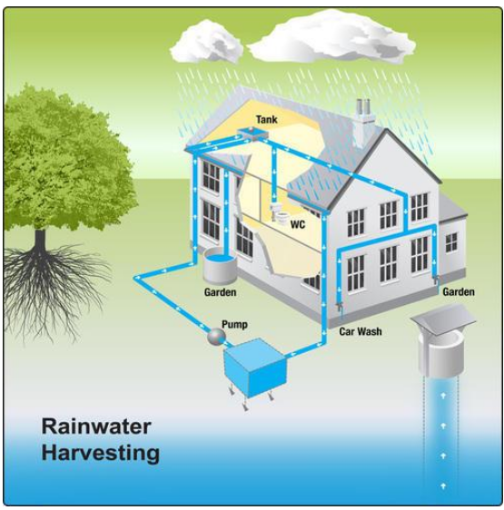

**Figure 8: Water harvesting or Rainwater harvesting**

* The rainwater that falls on the earth is generally allowed to flow away.
* However, it can be saved and used to replenish the groundwater levels of the Earth. This process of preventing rainwater from flowing away and storing it for different purposes such as replenishing groundwater levels, household chores or industrial purposes is called rainwater harvesting.

**Bawris**

An ancient practice of storing water involved construction of Bawris. In old times rainwater was collected in Bawris. However, with time their usage declined. Now due to scanty rainfall people are again using them to solve the problem of water storage.

**Drip Irrigation**

* It is an allocation technique used by farmers to water their fields.
* In this, water is allowed to slowly drip into the plants so that their water directly gets into the roots of the plants.
* This minimizes evaporation, saves water and allows the nutrients to reach the plants easily.
* Narrow tubes are used to make water reach the roots of the plants in drip irrigation.

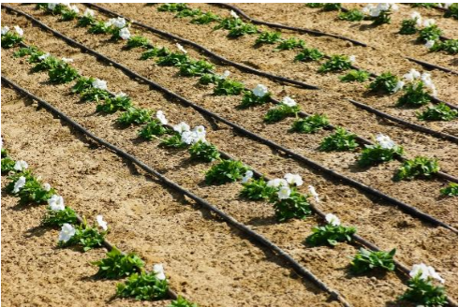

**Figure 9: Drip irrigation**

**How can we save water?**

We can adopt different ways to minimize the wastage of water:

* Always keep the taps closed while brushing or washing the face to prevent water from flowing away unnecessarily. One should use it only when needed.
* Fix any water taps that are leaking, immediately.
* Instead of taking a shower use a bucket to take bath.
* Use water left from washing clothes for mopping the floor and washing cars instead of running water.
* Water your plans in the morning or evening times so that the water does not immediately get evaporated.
* Do not waste food as it takes a lot of water to irrigate the fruits and vegetables.
* Do not throw away water unnecessarily. Use water in a judicious amount

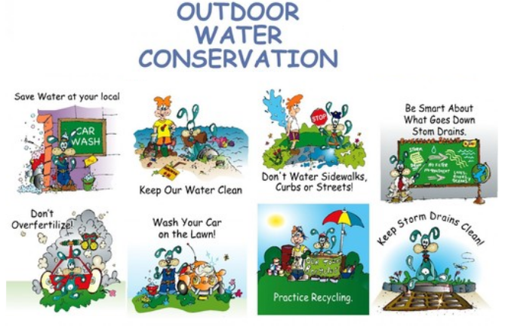

**Figure 10: Outdoor Water Conservation Tips**

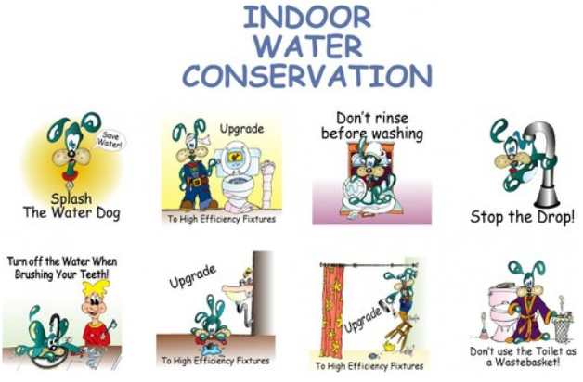

**Figure 11: Indoor Water Conservation Tips**

**How scarcity of water affects the plants?**

* The plants get dried up as they get no water and hence they can die.
* There is no water to conduct photosynthesis and hence they are not able to produce any food.
* They will not be able to grow upright because of scarce water.
* They will no longer be able to get enough nutrients from the soil because of less or water.
* As a result, there will be no food, no oxygen and hence no life without the plants.